Digital Transformation - Decision Management Plan
Program Management Plan

Introduction

Purpose
The objective of a Program Decision Management Plan is to ensure key decisions that impact the Program are properly reviewed, confirmed and approved by the relevant Stakeholders, Committees, or Executive Leadership team.

Scope
The scope of the Program Decision Management Plan includes decisions that are required in support of the Program scope, budget and schedule where there is no clear consensus on the approach and/or there are multiple options available to be chosen.
Decisions Requests for items that are not within the current scope of the Program should follow the Change Request process.

The Program Owner and Program Manager will lead the Program team in completing the phases of the Program Decision Management Process described in this document. The Decision Management Process will track and manage key Requests for Decisions (RFD) raised throughout the duration of the Program to completion.

Overview
The Program team will create and maintain a Program Decision Request Log as part of the Program Log that identifies the key decisions that are made during the Program. The Program Decision Management Plan will be reviewed by the Program Manager with the Program Owners to ensure there is agreement on how decisions will be made and who has authority to make them.

Roles and Responsibilities
The following key roles and responsibilities are defined in supporting the Decision Management process.

Role | Key Responsibilities
Program Manager (or Project Manager if applicable) | - Ensure the Program Decision Management process is followed;  - Ensure a Decision Request Owner is assigned; and  - Ensure decisions are reached for all Program related decision requests.
Program Owners | - Support the Program Manager in reaching decisions for all Decision Requests; and  - Approve or facilitate approval for Decision Requests.
Decision Request Owner | - Complete the Analysis phase of the Program Decision Management process; and  - Support the Program Manager in the Submission process.
Program Team Member(s) | - Initiate Decision Requests as required; and  - Participate in the analysis phase as required.

Program Decision Management Process
The Decision Management Process consists of seven phases. These phases will cover the entire process of managing key decisions through a Program. The following diagram outlines the high level process phases.

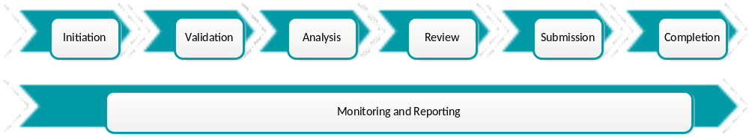

Phase 1 - Initiation
The following tasks are performed during the Initiation phase:
- Any team member can initiate a decision request by providing the details to the Program Manager; and
- The Program Manager will enter the details into ServiceNow PPM.

Phase 2 – Validation
The following tasks are performed during the Validation phase:
- The Program Manager will validate the decision requested with the Program Owners;
- The Program Manager will assign a Decision Request Owner (if proceeding);
- The Program Manager will update the Decision Log with the information and notify the Decision Request Owner; and
- The Program Manager will meet with the Decision Request Owner to transfer the RFD to them.

Phase 3 - Analysis
The following tasks are performed during the Analysis phase:
- The Decision Request Owner will identify and engage the business areas required;
- The Decision Request Owner will create a Request for Decision following the Request for Decision Template including analysis, alternatives, impacts, etc.;
- The Decision Request Owner will store the Request for Decision document in the Program SharePoint folder;
- The Decision Request Owner will notify the Program Manager when the Request for Decision document is ready for review; and
- The Program Manager will update the Decision in ServiceNow PPM, if required.

Phase 4 - Review
The following tasks are performed during the Review phase:
- The Program Manager will perform a quality review of the Request for Decision document; and
- The Program Manager will schedule meetings with the Decision Request Owner as required.

Phase 5 - Submission
- The Program Manager will review the Request for Decision document with the Program Owners;
- The Program Manager will update the Request for Decision document as required;
- The Program Manager will submit the Request for Decision document to the Program Owners, Executive Steering Committee, and Executive Sponsors as required;
- The Program Manager will update the Decision in ServiceNow PPM, if required.

Phase 6 - Completion
- Once a decision is made, the Program Manager will update the Decision with comments and the Status to “Completed”; and
- The Program Manager will notify the Decision Request Owner of the decision.

Phase 7 – Monitoring/Reporting
- The Program Manager will monitor the Request for Decision to ensure that a decision is reached;
- The Program Manager is responsible to track the status of all Program-specific Requests for Decision, including managing any required escalations, defining prioritization of multiple requests, identification of decision due dates, etc.;
- The Program Manager will ensure Request for Decision updates are communicated to the applicable Program team members verbally and that the Decision is ServiceNow PPM applicable Request for Decision entry is updated with the decision made or further actions requested. These updates to the Decision in ServiceNow PPM will also include a link to the approved minutes held to review the Request(s) for Decision; and
- The Program Manager summarizes and reports on key Program Requests for Decision to the Program Owners, who will present to the Executive Sponsor, or Executive Steering Committee as needed.

